

III SEMESTER MCA
IN-SEMESTER EXAMINATION – 1 (SEPT’22)
SUBJECT: Machine Learning [MCA 5152]

Date: 03/09/2022 Max. Marks: 15
Time of Exam: 10:00AM –11:00 AM

Instructions to Candidates:
- Answer ALL the questions.
- For any calculations, all important steps need to be properly written.
- Use of Calculator is allowed. Use of Mobile is NOT allowed
- Missing data may be suitably assumed.

1A. | Differentiate between reinforcement and unsupervised learning. | 1
Unsupervised machine learning, uses machine learning algorithms to analyze and cluster unlabeled datasets. These algorithms discover hidden patterns or data groupings from untagged data without the need for human intervention.
Reinforcement learning is a machine learning training method based on rewarding desired behaviors and/or punishing undesired ones. In general, a reinforcement learning agent is able to perceive and interpret its environment, take actions and learn through trial and error.
1B. | How does gradient descent approach impacts on model performance improvement? | 1
 | Gradient descent is an optimization algorithm which is commonly-used to train machine learning models and neural networks. It is the process of minimizing a function by following the gradients of the cost function. This involves knowing the form of the cost as well as the derivative so that from a given point you know the gradient and can move in that direction, e.g. downhill towards the minimum value. Training data helps these models learn over time, and the cost function within gradient descent specifically acts as a barometer, gauging its accuracy with each iteration of parameter updates.
1C. | Differentiate between model overfitting and underfitting. | 1
Overfitting model tries to cover all/more than required data points present in given dataset. Model starts catching noise/inaccurate values present in dataset. Model can’t generalize or fit well on unseen dataset, and reduce model accuracy. Error on testing or validation dataset is much greater than error on training dataset.
Opposite of overfitting is underfitting. Underfitting is when model is not able to capture underlying trend of data. To avoid overfitting in model, volume/time of training data is compromised. Hence, model is not able to learn enough from training data, and hence it reduces accuracy and produces unreliable predictions.
1D. | With example, highlight the importance of dimensionality reduction. | 1
Dimensionality: number of input variables or features for a dataset.
Dimensionality reduction: techniques that reduce number of input variables in a dataset.
Benefits of applying Dimensionality Reduction
- Space required to store the dataset also gets reduced.
- Less Computation training time is required.
- Help in visualizing the data quickly.
- Removes the redundant features (if present)
1E. | What is loss function? List few loss functions and their formulae. | 1
The loss function is a method of evaluating how well the machine learning algorithm models featured data set. Loss functions are a measurement of how good the model is in terms of predicting the expected outcome.
Mean Absolute Error (MAE): simple metric; Not preferred where outliers are prominent.
Mean Squared Error (MSE): most common metric for regression models.
Root Mean Squared Error (RMSE): square root MSE.
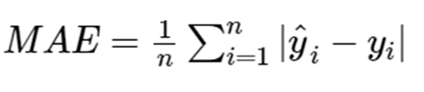
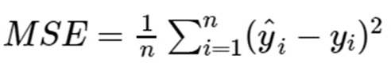
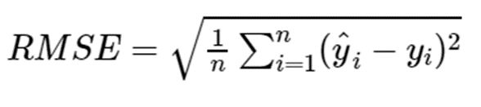
2A. | A fair coin is tossed ‘n’ number of times. If probability of occurrence of a head 6 times is same as the probability that a head comes 8 times, then find the value of n. | 2
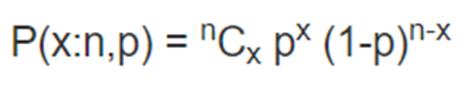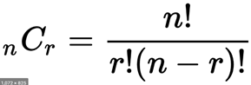
Fair coin --> p, q = 0.5
P(6:n,0.5) =P(8:n,0.5) --> n = 14
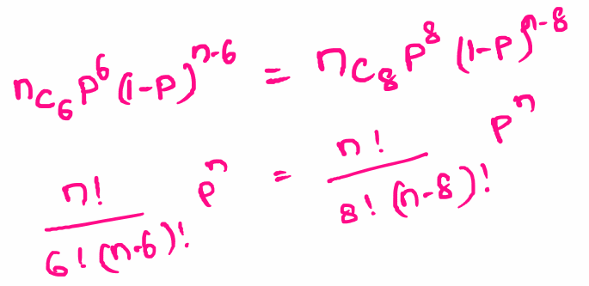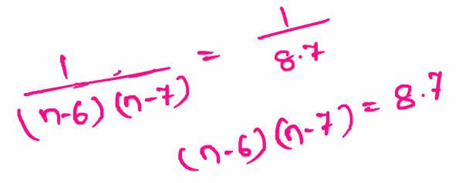
Equality Equation | 1.0 marks
Solution Process | 0.5 marks
Correct Answer | 0.5 marks

2B. | Use Fig 1.1 to compute the respective recall and precision for Setosa and Versicolor classes. | 2
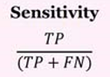
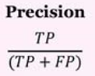
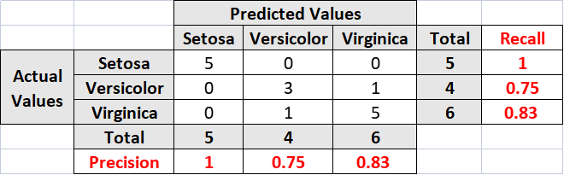

Only Formula | 0.5 marks
Each correct answer (4) | 0.5 marks
Wrong Answer//correct process | 1.0 marks

3A. | Table 1.1 shows a set of 10 hypothetical records of soccer players extracted from a large database. Use this table to answer the following question.  Use Ordinary Least Square (OLS) estimation to calculate the regression coefficients for the given date, considering ‘performance score’ as independent variable, and ‘Fee/season’ as dependent variable. | 3
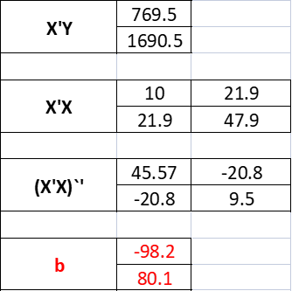
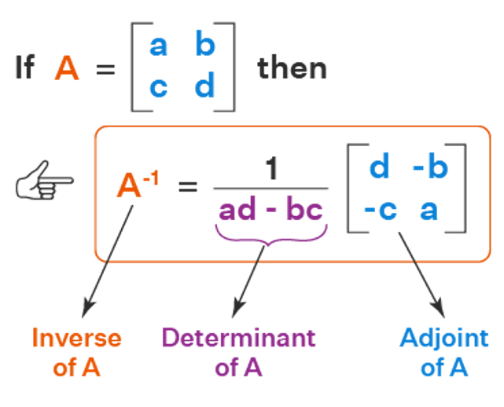
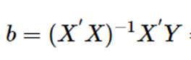
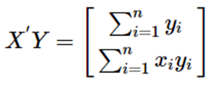

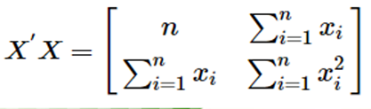

Data Table Complete | 1.5 marks
Matrix process | 1.0 marks
Correct Answer | 0.5 marks

3B. | Consider the following data set, describing CARS  Display count of cars, average MPG, minimum weight and maximum displacement of cars with 8 and 4 cylinders in a tabular format.  Calculate the coefficient of correlation value between the attributes “Horse Power” and “Cylinders” in the above dataset. | 3
  Names | Cylinders | Displace  ment | Horse-power | Weight | Accele  ration | Model Year | Country of Origin | MPG
  Chevrolet Chevelle | 8 | 307 | 130 | 3504 | 12 | 1970 | 1 | 18
  Plymouth Duster | 6 | 198 | 95 | 2833 | 15.5 | 1978 | 1 | 20
  Chevrolet Vega (SW) | 4 | 140 | 72 | 2408 | 19 | 1971 | 1 | 22
  Fiat 124B | 4 | 88 | 76 | 2065 | 14.5 | 1971 | 2 | 30
  Datsun 1200 | 4 | 72 | 69 | 1613 | 18 | 1975 | 3 | 35
  Buick Skylark 320 | 8 | 350 | 165 | 3693 | 11.5 | 1972 | 1 | 15
  Ford Maverick | 6 | 200 | 85 | 2587 | 16 | 1975 | 1 | 21
  Volkswagen 1131 | 4 | 97 | 46 | 1835 | 20.5 | 1970 | 2 | 19
  Toyota Corolla | 4 | 71 | 65 | 1773 | 19 | 1973 | 3 | 31
  Ford Torino | 8 | 302 | 140 | 3449 | 10.5 | 1970 | 1 | 17
Ans | 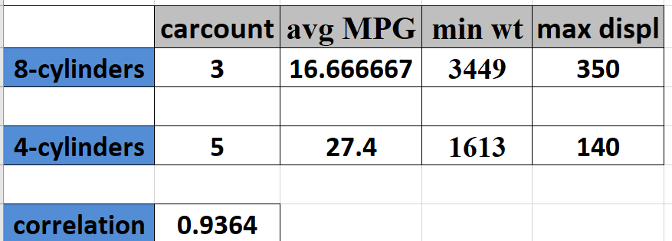

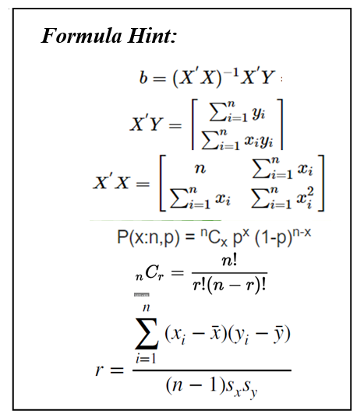

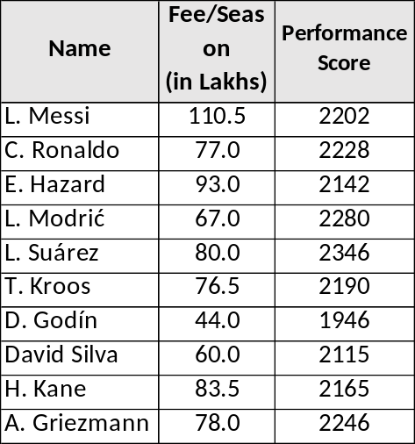

Table 1.1: Soccer player Record

* * * * *

